**Deployment of a Static Web-Application**

**Contents to check while deployment :**

* Properties of application.
* Port No. to which the web-application is assigned for deployment.

**Requirements for Deployment:**

* OS.
* Server.
* Region to reduce latency/Response time.
* We have to install Web-server, unzip, net-tools to our server.

**Steps to deploy a static web-application:**

1. Create a EC2 server using AWS account.

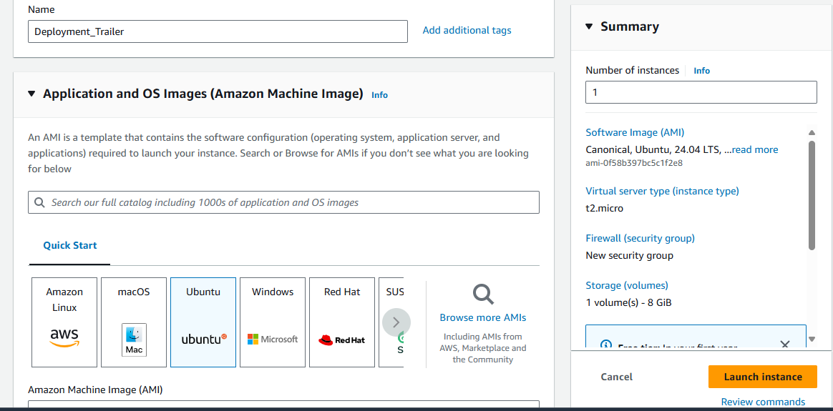

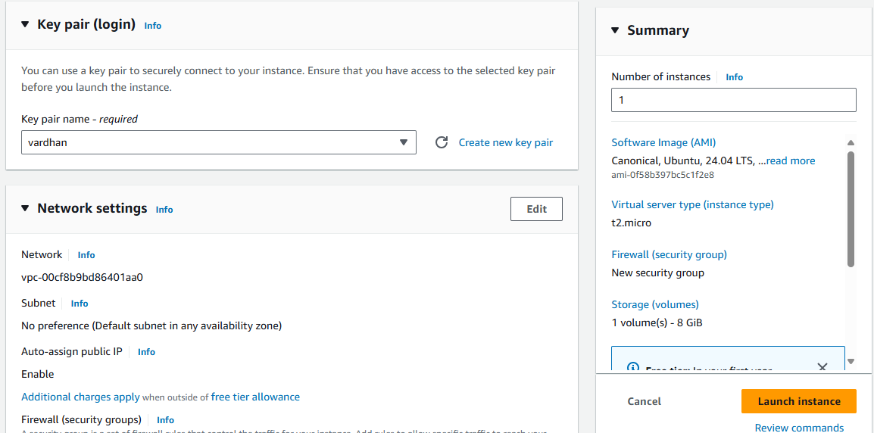

1. Login to the server using SSH. Here we are using Mobaxterm.

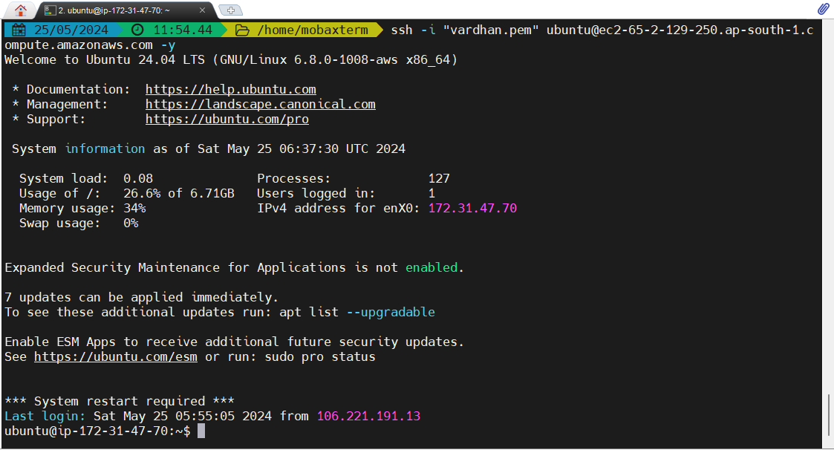

1. Update your server using ‘apt update’ command.

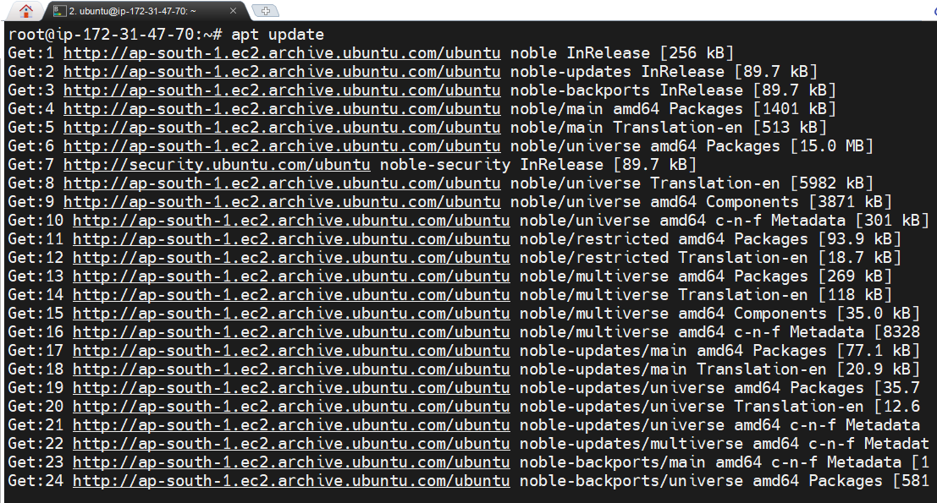

1. Install Web-server using

apt install apache2 --> for Ubuntu Linux.

yum install httpd --> for Amazon Linux.

In Ubuntu the webserver will be initially in running/ active state.

In Amazon Linux the webserver initially in dead/ inactive state. In order to active our webserver in Amazon Linux we have to restart and enable the webserver using ‘systemctl’ commands.

systemctl restart <webserver> --> To restart the webserver.

systemctl enable <webserver> --> To enable the webserver

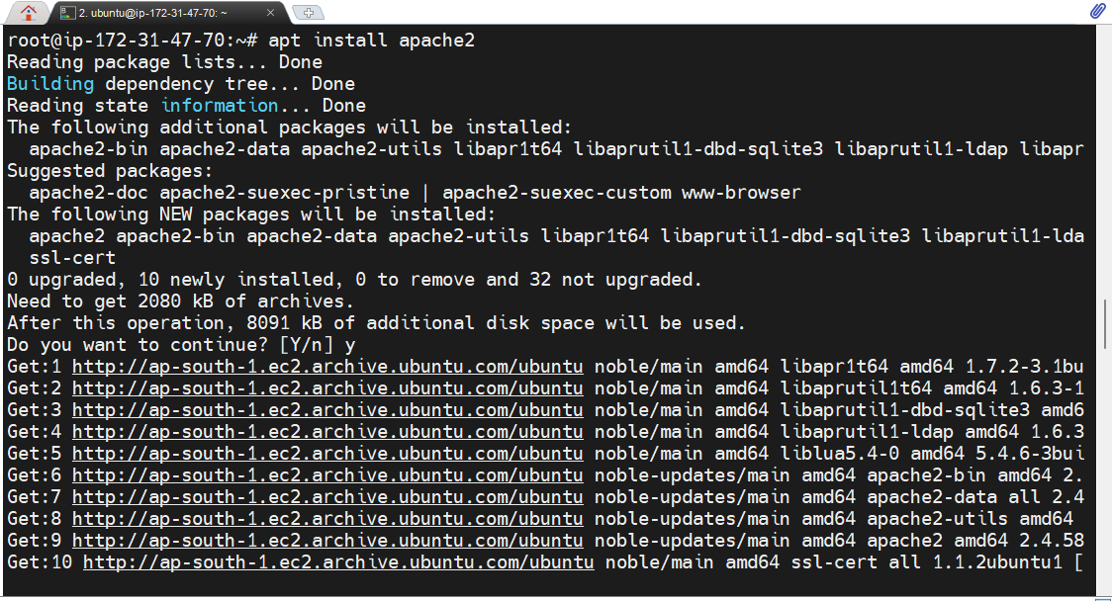

1. Import your web application in zip format using Mobaxterm upload button present in menu left side.

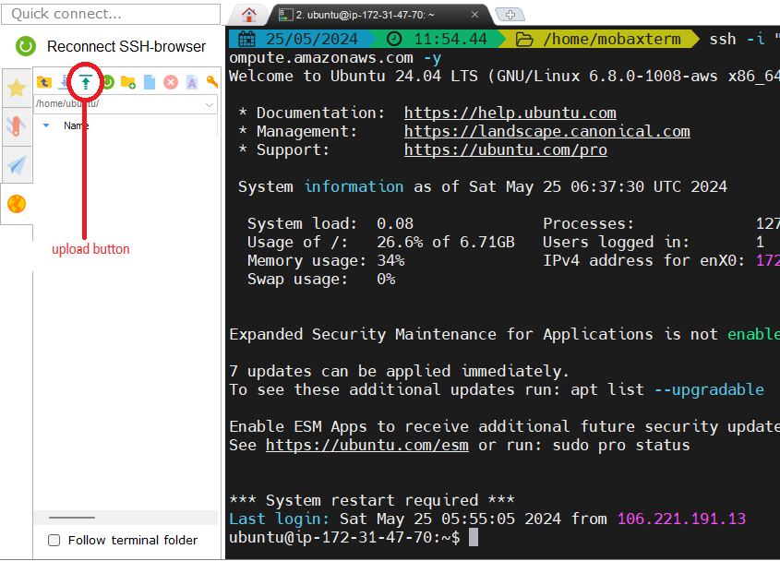

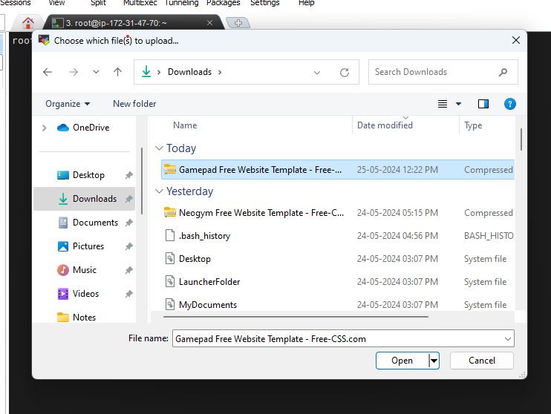

1. In order to unzip the imported file, we need to install unzip to our server using ‘apt install unzip’ command.

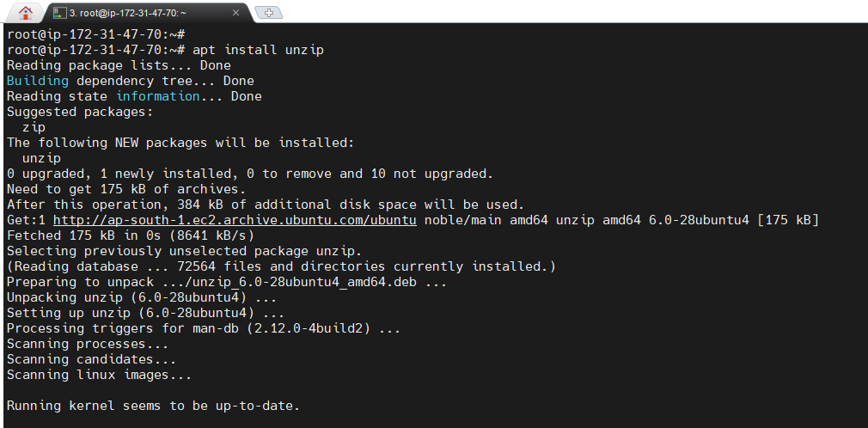

1. Unzip the file using ‘unzip <filepath>’.

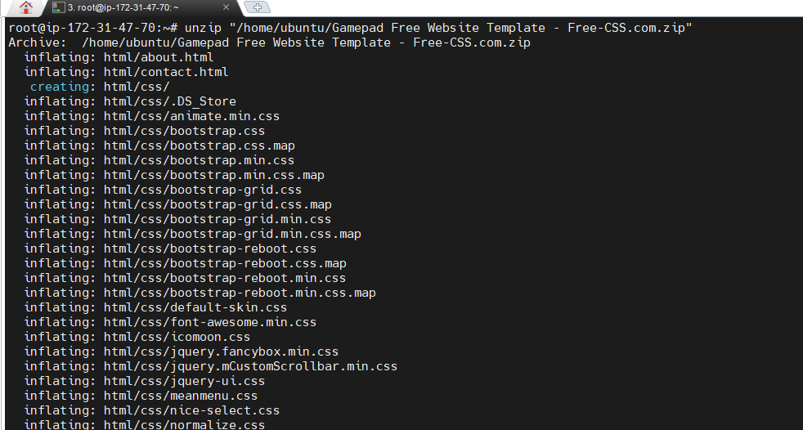

1. Now remove the zip file.

command --> rm <zip file>

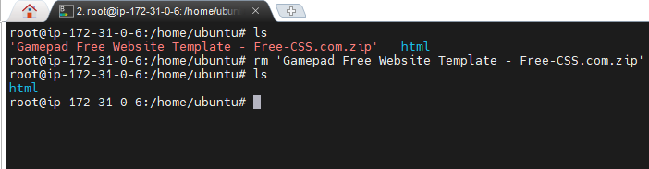

1. Now copy the unzipped files to the default location of web server.

i.e, /var/www/html

command --> cp -rf /home/ubuntu/html/* /var/www/html

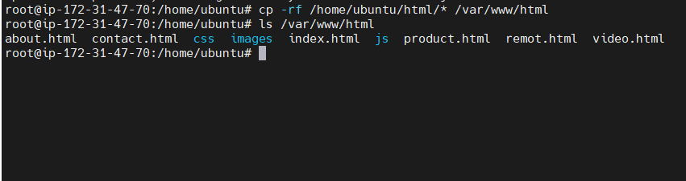

1. Check whether the webserver port is actively listening or not using both netstat and telnet commands.

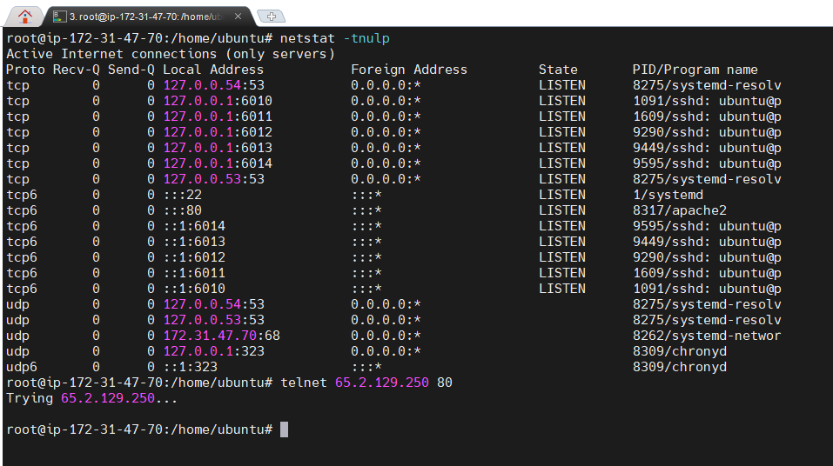

1. It webserver port is not actively listening allow it in security groups inbound rules and then check whether the web-server port is listening.

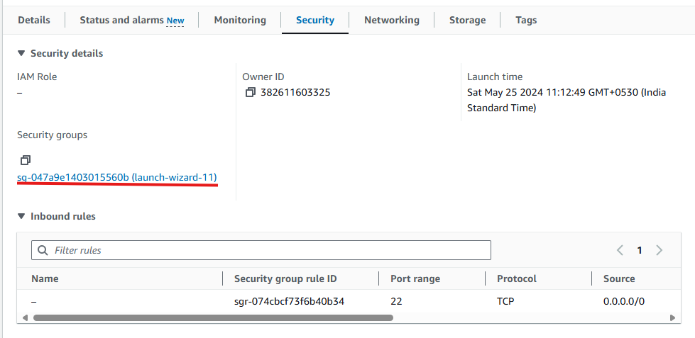

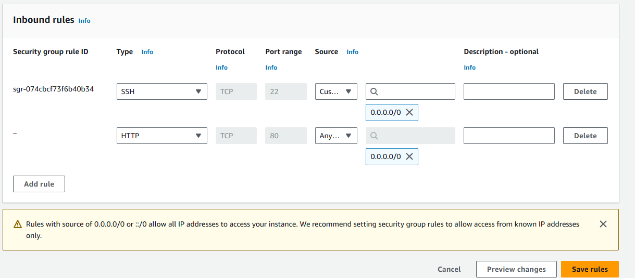

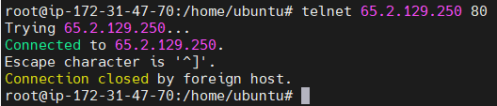

By this step the deployment is completed.

In order to check whether the deployment is success or not you have to enter the public IP of your server in URL of any browser.

